Visual Figaro Installation
The zip file contains a portable version of Jedit and Visual Figaro (plus maybe the Figaro models solvers FIGSEQ and YAMS, see special notice at the end of the present instructions). Installation essentially consists in un-zipping all files in a directory where you have write privileges.
More precisely, here is the procedure to follow, in terms of screen shots:
After un-zipping, here are the contents of the obtained directory:
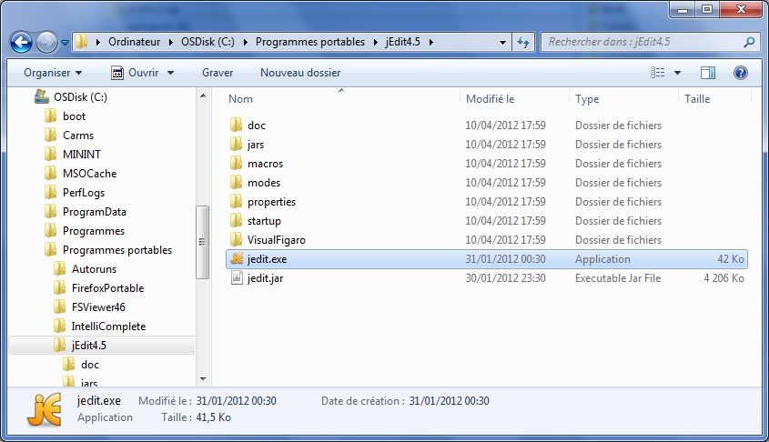
Double click on Jedit.exe. Once Jedit is launched, activate the Visual Figaro plugin from the "Plugins" menu.
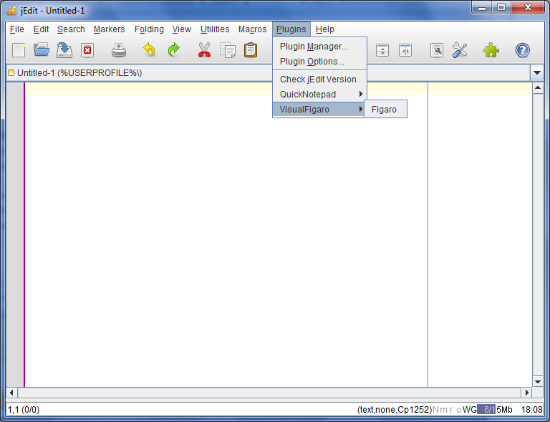
When the Visual Figaro window pops up, click on the small black triangle and select the option « Dock at Left ».
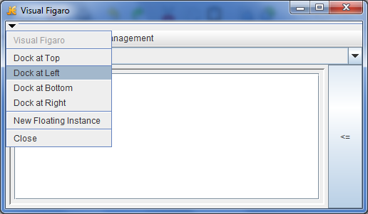
Then you get the following presentation:
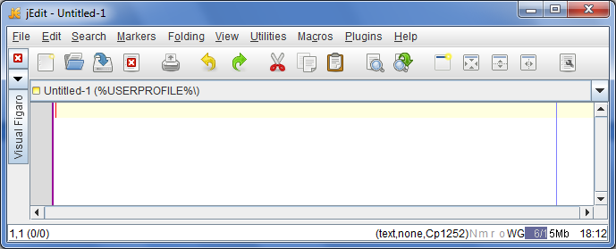

With a click on the Visual Figaro button on the left, you can display the plugin sub-window and you get the final presentation:
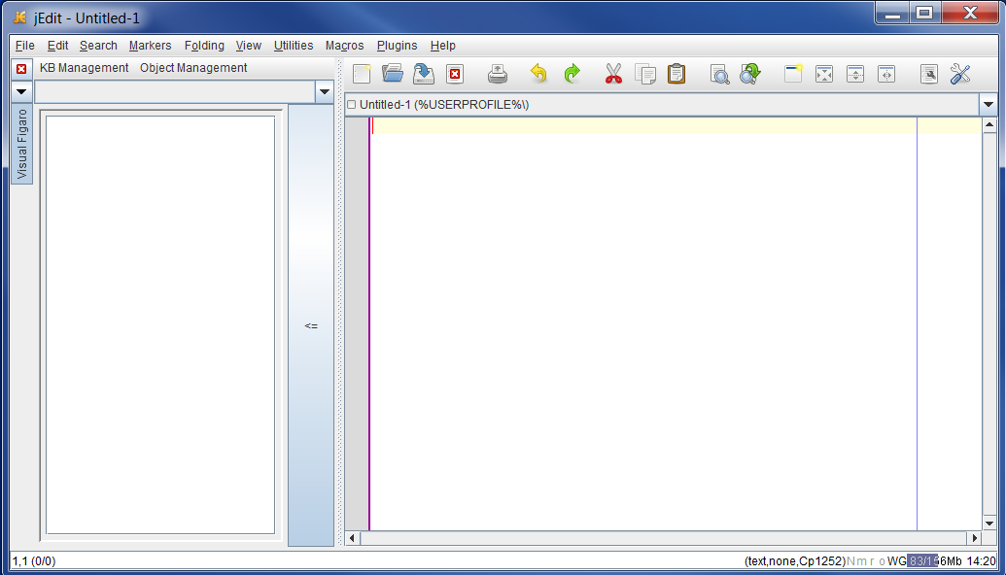
Then, you can load a knowledge base thanks to the menu « KB management » :
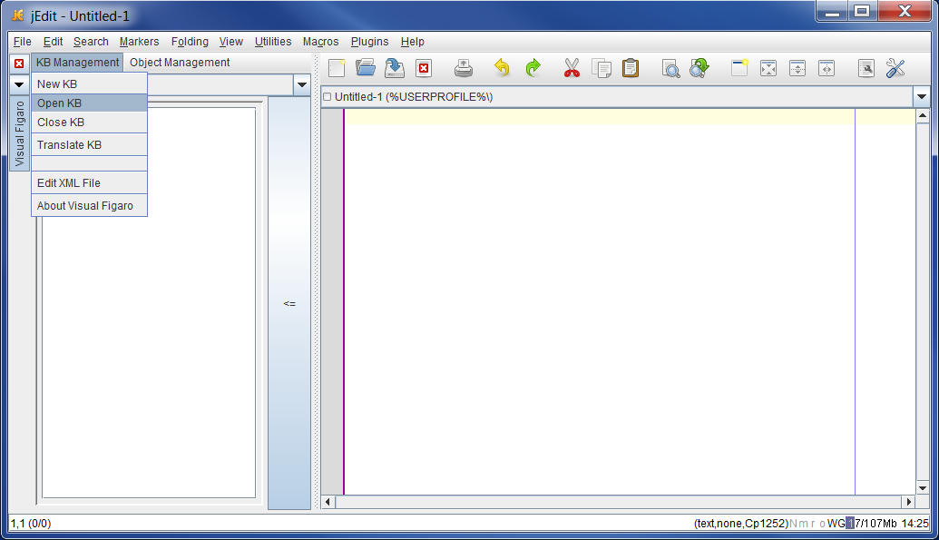
Knowledge bases are in a separate zip file, called "Sample knowledge bases for KB3".
To create or load a system model, use the menu « Object Management »:
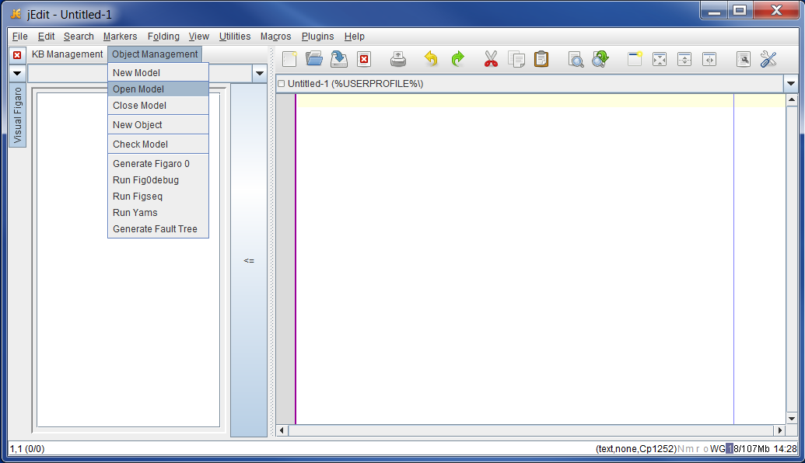t
Please note that before opening a model, you need to first open its associated knowledge base. In the window displayed by the "Open Model" command, you have to choose the knowledge base you want to associate to the model among the list of open knowledge bases.

Installation of FIGSEQ and YAMS
Depending on the provided package, these tools are included or not in the zip file (it is not necessary to include them if they are already installed in association with KB3). Visual Figaro looks for these tools according to the following procedure:
- In a first step, VF looks for FIGSEQ in a subdirectory called "FIGSEQ" of the directory VisualFIgaro, then it looks for it in the configuration file of KB3, called KB3configuration.xml
- In a first step, VF looks for YAMS in a subdirectory called "YAMS" of the directory VisualFIgaro, then it looks for it in KB3configuration.xml
Therefore, it is possible to have an entirely portable installation of the FIGARO tools, including FIGSEQ and YAMS.

